
Test № 1
I Future continuous:
- This time next week I ___________________ (lie) on a beach in Miami.
- When I get home from work tonight, my kids ___________________(play) video games.
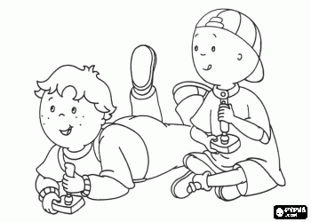
- What ___________________ you ___________________ (do) in ten years’ time?
- At this rate, they ___________________(speak) French fluently in six months.
- Don’t phone between 8 and 9. They ___________________ (have) dinner then.
- ___________________ you ___________________ (use) the laptop computer this afternoon? I’m going to need it.
- She ___________________(leave) school this time next year.

II Future simple VS Future continuous:
- I ______________ (work) in the garden all day long tomorrow.
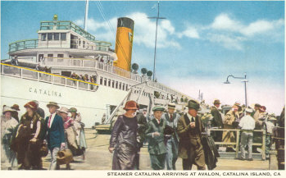
- I _____________ (finish) the book by the evening.
- Не ______________ (be) tired after his work.
- He can't come at two o'clock tomorrow because he _____________________ (work) at that time.
- Не _______________ (send) us a telegram as soon as the steamer arrives.
- While my mother is having her breakfast. I _____________ (read) the newspaper.
Steamer Catalina arriving at Avalon
III Fill in with: Present Continuous, Present Simple, Future Simple, Future Continuous
- The course ………………………. (begin) in October.
- You can’t come with me. Dad ………………….. (not / let) you.
- This time next week I …………………… (have) breakfast with my sister in Paris!
- Do you have any plans for tonight? – Actually, I do. I ……………………… (go) out with Penny.

IV Answer the questions in writing. What tense did you use?
- What will you be doing tomorrow?_________________________________________
______________________________________________________________________________________________________________________________
- What will you be doing one week from now?_____________________________________________________________________________
________________________________________________________________________________________________________________________________
- What will you be doing one year from now?________________________________________________________________
__________________________________________________________________________________________________________________________
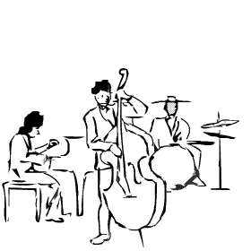
Test № 2
I Future continuous:
- People in refugee camps ___________________(not live) in better conditions in five years’ time.
- If we get there late, they ___________________(sleep)
- You can call now because they ___________________(not sleep).
- This Sunday, ___________________ you ___________________(play) squash with Liam as usual?
No, I won’t because he _____________ (get ) married then.
- ___________________ your brother’s band ___________________((play) at the jazz festival next week?
No, Actually, they _______________(perform) in New York then.
- We ___________________(not go) on holiday next year unless the economy picks up.
- We ___________________(not spend) Christmas at our country house if they don’t get the roof repaired on time.
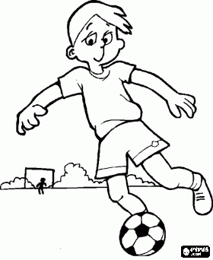
II Future simple VS Future continuous:

- He_________________ (ring) you up and tell you everything about the forthcoming meeting.
- They _______________________ (not, play) football on Sunday afternoon.
- He ________________ (carry) this bag for you.
- In June that firm ______________________ (carry) on negotiations for the purchase of software.
- In summer the director __________________ (still, work) on her new film.
- She _________________ (not, go) to the party with us.


Fill in with: Present Continuous, Present Simple, Future Simple, Future Continuous
- The course ………………………. (begin) in October.
- You can’t come with me. Dad ………………….. (not / let) you.
- This time next week I …………………… (have) breakfast with my sister in Paris!
- Do you have any plans for tonight? – Actually, I do. I ……………………… (go) out with Penny.
IV Answer the questions in writing. What tense did you use?
- Imagine yourself being now on the tropical beach. What are you doing there?_________________________________________
_________________________________________________________________________________________________________________________________
- What do people do every day at work? ____________________________________________________________________________________
___________________________________________________________________________________________________________________________________
- What were you doing today from 7pm. To 9pm.?________________________________________________________________________
___________________________________________________________________________________________________________________________________

